Coordinated Capital Improvements Program (CCIP) Request for Proposals and Application

2017 Application Cycle
Return to: South Washington Watershed District
2302 Tower Dr.
Woodbury, MN 55125
john.loomis@woodburymn.gov

Due by: March 24, 2017 at 4:00 p.m.

Overview
As a result of developing and implementing its water resource management plan, working with local government units within the watershed on local water plans and capital projects, and carrying out its permitting program, the District is aware of the challenges posed to sound, comprehensive surface water management by existing urban development. Existing development and impervious surface within the watershed constructed at an earlier time may not have applied due attention to minimizing and managing stormwater impacts under pre-existing regulatory conditions. Stormwater management in these areas may be improved through retrofitting and during redevelopment. However, space and available options often are constrained and measures may be expensive.
To facilitate actions to improve stormwater management in existing developed areas, the District administers a Coordinated Capital Improvement Program (CCIP) to provide financial assistance to local land use and public works authorities for water quality improvement projects. The CCIP seeks to:
- Facilitate local government units within the District to explore water quality improvement opportunities and incorporate those opportunities into routine infrastructure operation and maintenance projects;
- Promote closer collaboration between local units and the District on water quality improvement efforts as an element of capital improvement plans;
- Foster stormwater management innovation and create demonstration/education examples; and
- Defray local costs in the broader, watershed-wide interest of improving water quality.

Applications are now being accepted for 2017 project funding. Awarded projects must be complete before Dec. 31, 2018. Grants may be awarded for up to 35% of the total project cost. CCIP grants are funded by stormwater utility fees, and therefore are allocated to projects in the SWWD Management Unit where the fees are collected. Up to $500,000 in CCIP funds will be allocated to projects in the South Washington Management Unit for 2016.

Eligibility
All municipalities and county agencies proposing projects within the South Washington Management Unit of the SWWD are eligible to apply. Capital improvements and maintenance projects are eligible. New and redevelopment projects must provide treatment beyond what is required by SWWD standards to be eligible.
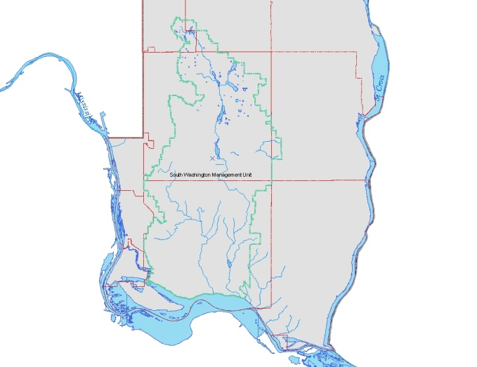

Selection Process
Applications will be evaluated by SWWD staff to determine overall water quality benefit and will rank projects based on their cost/benefit. Funding allocations will be determined by the SWWD Board of Managers at their April Board meeting. The Board reserves the right to deny all applications.

All grants will be awarded contingent on approval following SWWD development review. Project designs must meet all SWWD standards and follow guidance provided in the SWWD standards manual. Development review applications for CCIP funded projects must include a maintenance plan for SWWD review. Grantees will be required to enter into an agreement with SWWD. Payment will be made following completion of the project and submission of final report to consist of as built plans and itemized invoice detailing total project costs.

Questions
Contact John Loomis at 651/714-3714 or john.loomis@woodburymn.gov

2017 SWWD Coordinated Capital Improvement Program Application

Applicant Information
LGU:
LGU Representative:
Address:
City: State: MN Zip Code:
Phone: Email:

Project Location
Project Location:
Watershed Management Unit: South Washington
Primary Waterbody Affected:

Project Description
Purpose/Need

Goals

Benefits/Measurable Results (e.g. estimated pollutant reductions, reduced flooding risk, etc.)

Project Budget
Total Project Cost:
CCIP Funding Requested (maximum of 35% of total project cost):
I certify to the best of my knowledge that the information included in this application is true, complete, and accurate
Signature Date

